Project Design Phase-I Problem Solution Fit Template

|  |  |
| --- | --- |
| Date | 18 September 2022 |
| Team ID | PNT2022TMID06675 |
| Project Name | Project – EMERGING METHODS FOR EARLY  DETECTION OF FOREST FIRES |
| Maximum Marks | 2 Marks |

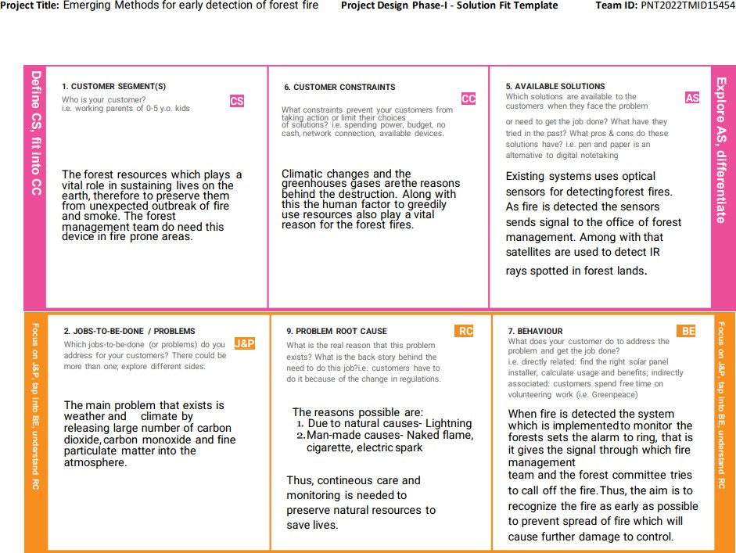



**Team ID:** PNT2022TMID06675

